**1) Installing Minikube (K8s)** 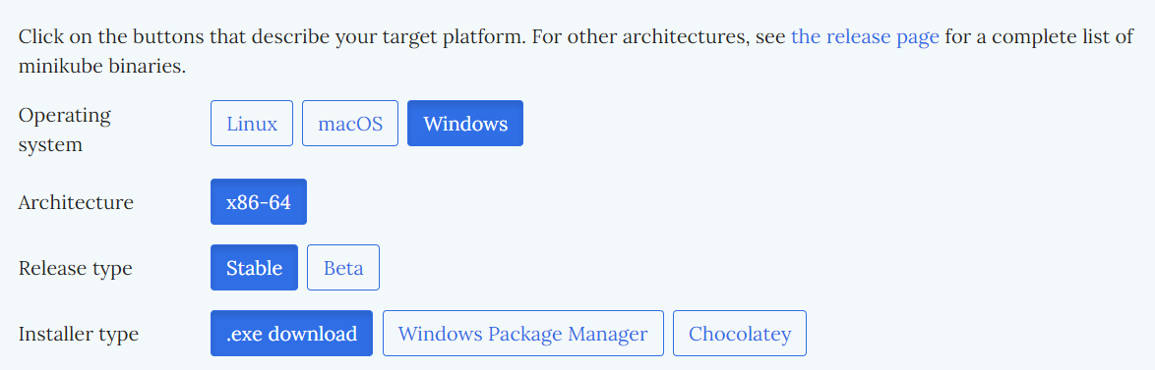

* **Go to minikube official website to choose the configuration**

**To install the latest minikube stable release on x86-64 Windows using .exe download:**

* **Using CMD, Execute this command :**

**New-Item -Path 'c:\' -Name 'minikube' -ItemType Directory -Force**

**Invoke-WebRequest -OutFile 'c:\minikube\minikube.exe' -Uri 'https://github.com/kubernetes/minikube/releases/latest/download/minikube-windows-amd64.exe' -UseBasicParsing**

* **The File will be created in the give Path**
* **Open powershell in the Installed path (make sure to run as administrator), Execute Command :**

**$oldPath = [Environment]::GetEnvironmentVariable('Path', [EnvironmentVariableTarget]::Machine)**

**if ($oldPath.Split(';') -inotcontains 'C:\minikube'){ `**

**[Environment]::SetEnvironmentVariable('Path', $('{0};C:\minikube' -f $oldPath), [EnvironmentVariableTarget]::Machine) `**

**}**

Minikube will be installed.

To check wether minikube is installed? Execute command - ***Minikube version***

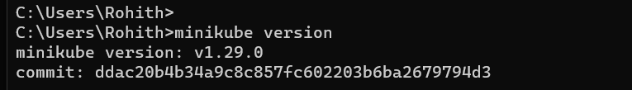

**2) Creating Deployment (pod & Services)**

* To start Minikube execute command

***~ Minikube start***

* Creating Ngnix Deployment

**kubectl create deployment nginxnew --image=nginx:1.14.2 --port=80**

Name => nginxnew (self-descriptive name)

-- Image => Name of the image and its version

-- Port => Defaut port no. of nginx server

To check the Deployment :

***~ Kubectl get deployments***

To check the Pod :

***~ kubectl get pod***

=>The Output is similar to :

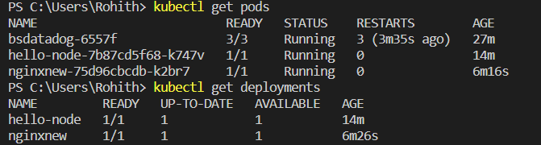

By default, the Pod is only accessible by its internal IP address within the Kubernetes cluster. To make the (nginxnew) Container accessible from outside the Kubernetes virtual network, you have to expose the Pod as a Kubernetes Service.

* Creating Service to the (Nginxnew) Pod

**kubectl expose deployment nginxnew --type=LoadBalancer --port=80**

The (--type=LoadBalancer) flag indicates that you want to expose your Service outside of the cluster.

To check the service :

***~ kubectl get services***

=> Output is similar to :

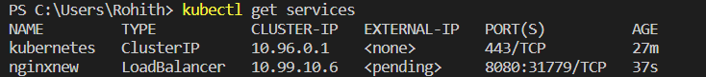

* To Start the Service & Redirect to the webpage Execute Command:

***~ Minikube Service <servicename> nginxnew***

Output After Redirecting:

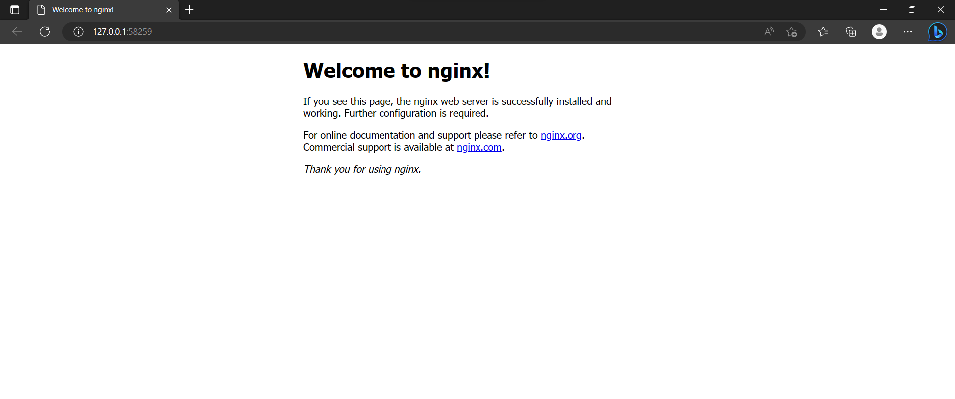

3)